Can you find 5 things in your house that start with the sound ‘s’ ?  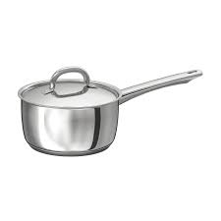  Can you find 5 things that start with the sound ‘t’?   | Please share a story with someone who lives at your house?   | Look out of your window, how many red cars can you count?   | Can you choose a small toy, like a car or a figure and freeze it in the freezer?  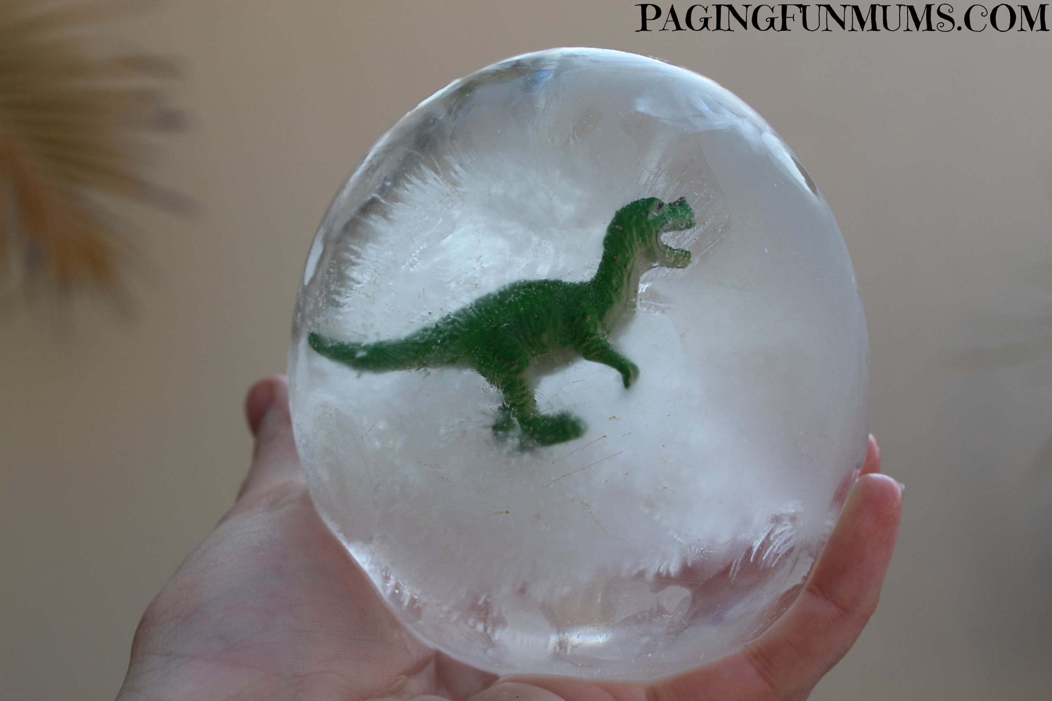 | Can you now defrost the ice and rescue the toy that was in there.  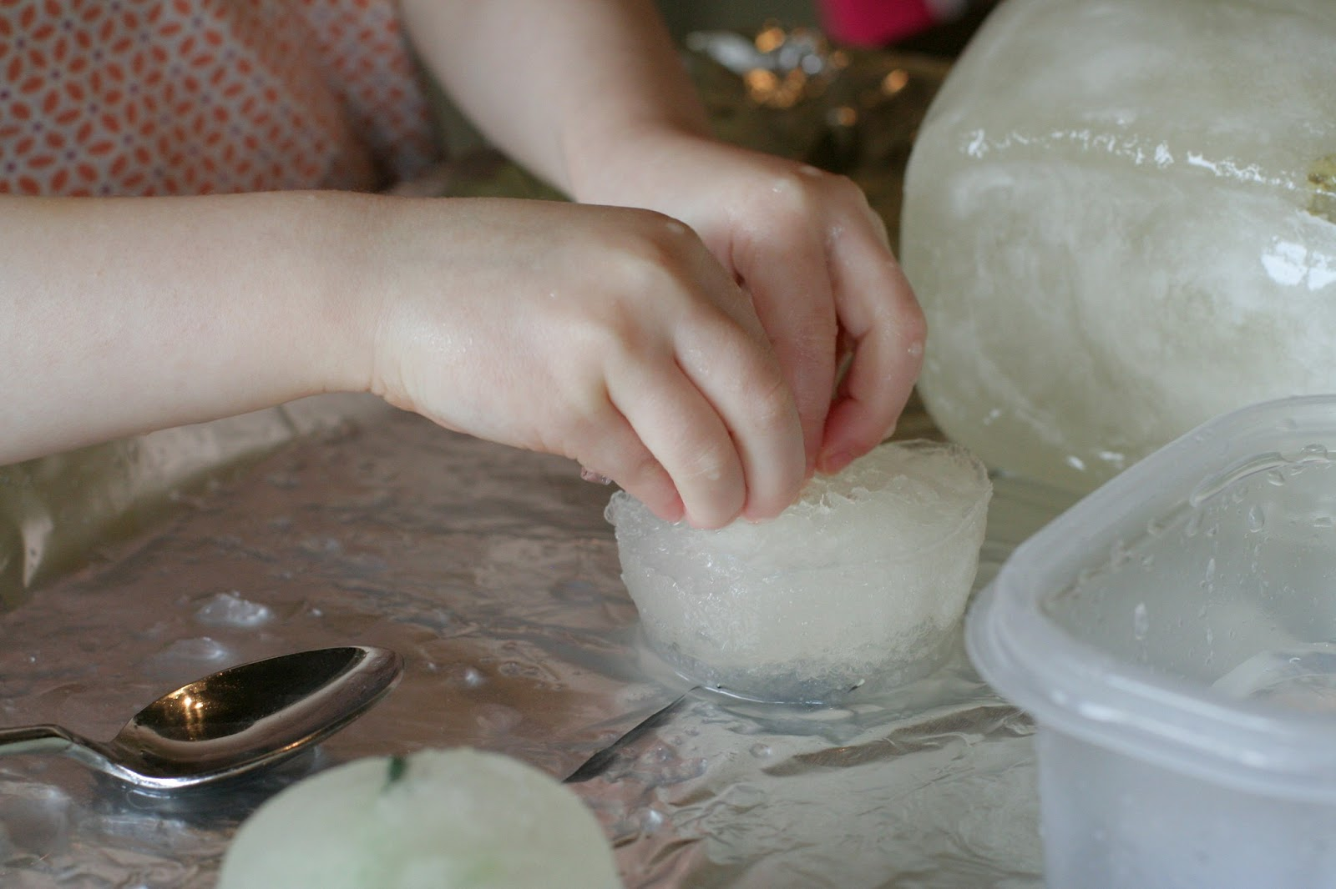
How many birds can you count in your garden or outside your house?  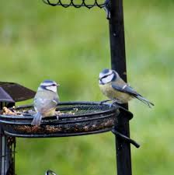 | Make some playdough with someone at home?  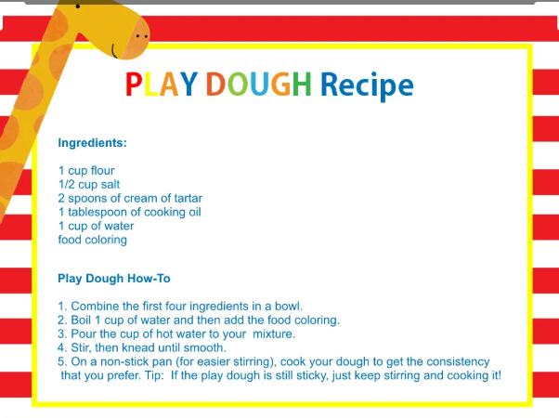 | Make a pasta necklace.  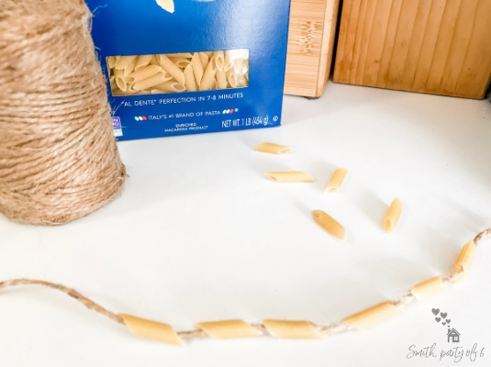 | Write your name in a tray of flour.  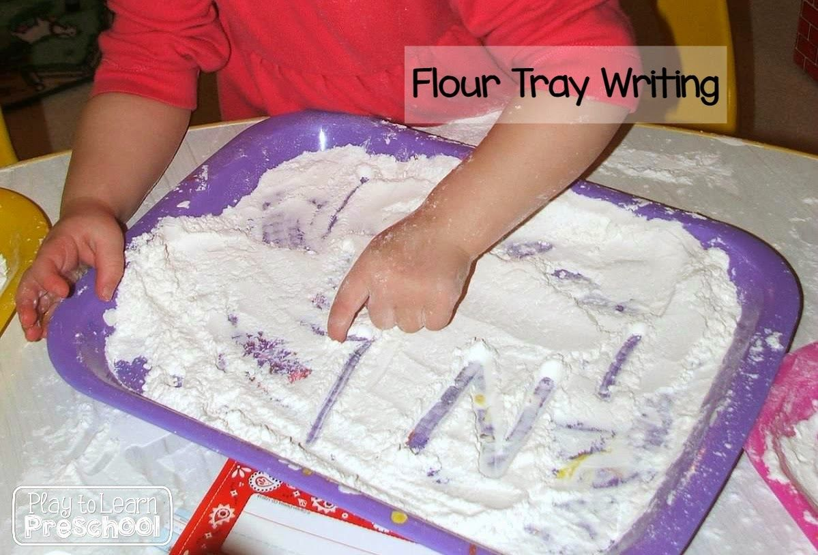 | Cut out some pictures of things you like from a magazine.  

